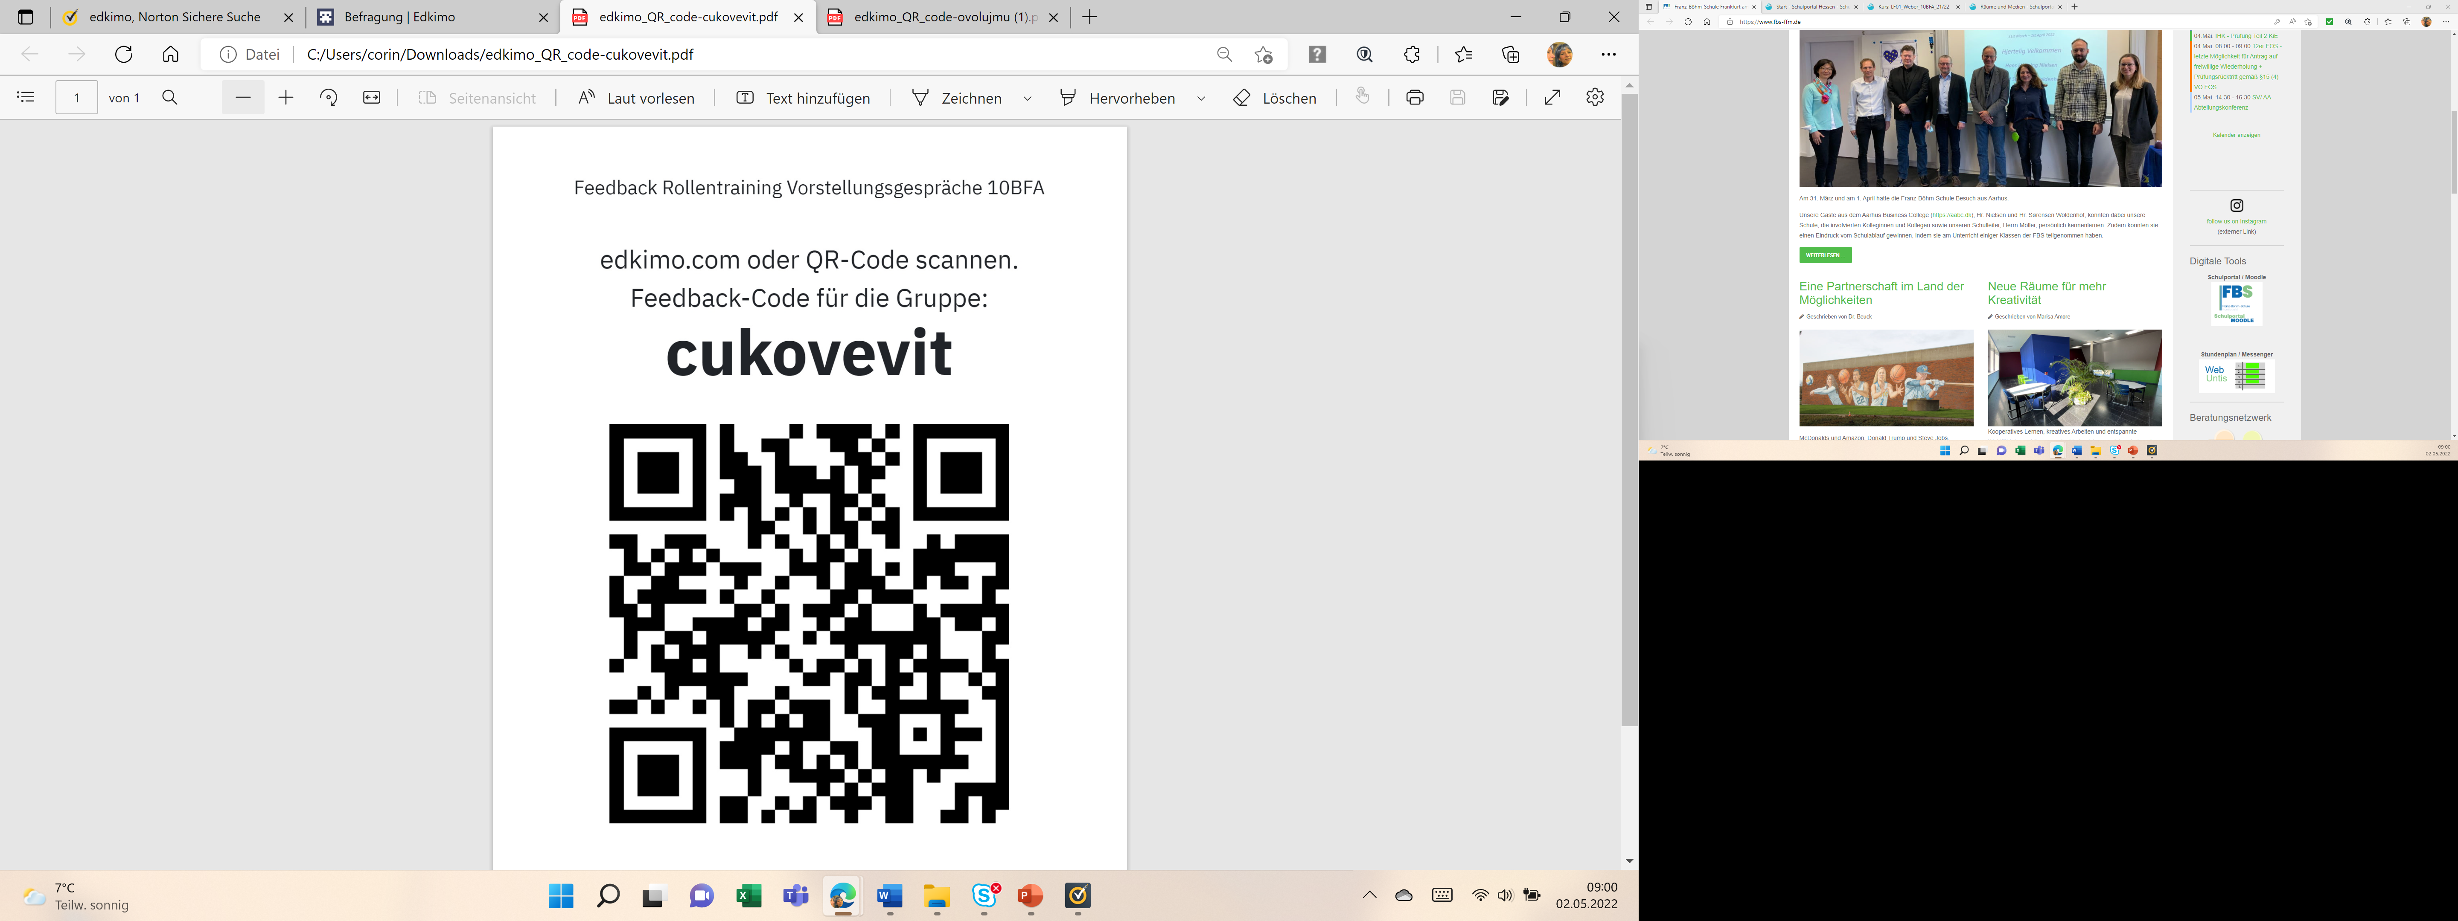

<https://app.edkimo.com/feedback/cukovevit>